CSE 344 - SYSTEM PROGRAMMING - HOMEWORK #4
THREADS AND SEMAPHORES
GÖKHAN HAS - 161044067

In this assignment, synchronization is requested between seven threads. One thread wholesaler, others were asked to be chef threads. Chef threads will only use one function, and communication between all threads will be done using semaphores.

In the assignment, the ingredients were asked to be kept in a data structure. I kept the ingredients using the array data structure. I used POSIX unnamed semaphores that I know from midterm project.

I want to talk about the input file at first. The input file consists of at least 10 lines and it is assumed that there is valid data in these lines. So here the user should not send 10 blank lines. Valid data must be entered. Because that's been said in homework.

I have determined which two ingredients are required for the Chefs for once. According to this determination, chefs need "sugar and walnuts", "flour and walnuts", "milk and sugar", "flour and sugar", "milk and walnuts", "milk and flour" materials, respectively. This sequence is maintained whenever the program runs. The order of materials can also vary among themselves.

I used mutex for sync problems. I solved these problems with Mutex. mutex, called mutex_chefAndWholesaler, provides communication between the wholesaler and the chefs. I draw attention here, the initial value is 0. Because when the wholesaler brings material, she/he should take the dessert. So he should wait until the dessert is ready. On the other hand, there is a mutex among the chefs. The name of this mutex is mutex_chefs. I planned so that the work of the chefs does not interfere and the chef only needs the ingredients she/he needs.

void errorExit(char* error) : When an error occurs, it normally ends the program and prints the error message

void printUsage() : Prints how to run the program.
int getValueFromSem(sem_t* sem) : Returns the current value of the semaphore taken as a parameter.

size_t getFileSize(const char* fileName) : Returns the number of bytes of the file name received as a parameter.
int getIngredients(char* str) : Returns which chef needs which ingredients, char * and is required to print the information message.

int whichChef(char* str) : Returns the number of which chef is working.

char* which(int chef) : Used for other chef information messages.

void* chef(void* chefId) : Mainly 6 threads will work (for the chef) is a common function. It takes the necessary ingredients and makes dessert.

int isThereAtLeastTenLine(int fd, int file_size) : Checks whether there are at least 10 lines in the file. There should be valid data in rows.

SCREENSHOTS

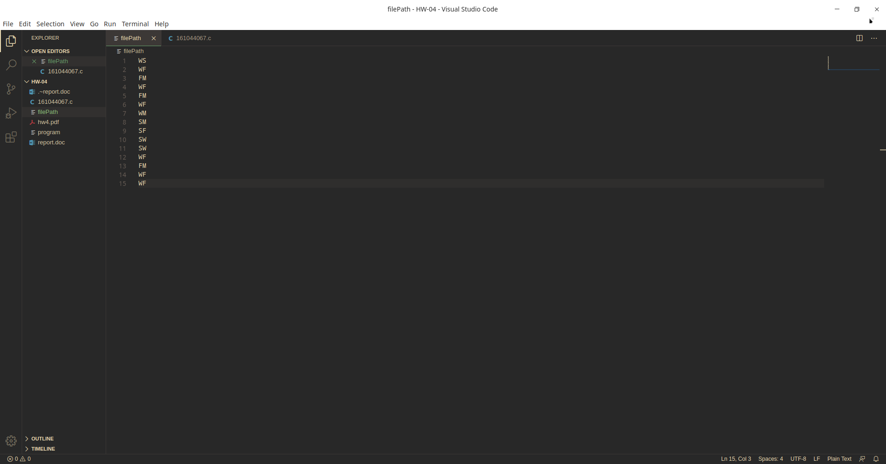
input file example

